

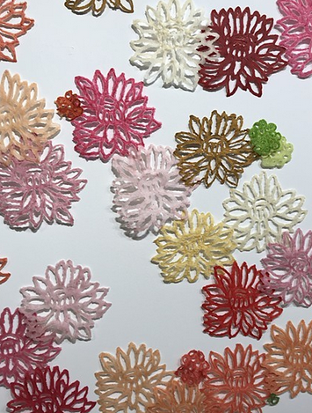***PRESS RELEASE  
  
In conjunction with the city-wide FiberFest,***

***Constellation Studios presents:***

***Paper Pulp & Beyond***

January 24 – February 28, 2020

Special Reception Thursday, January 23, 7-8pm

Papermaking demos - First Friday Feb 7, 6-8pm

Artists:

Kathy Cartier, Lincoln, NE

Melissa Harshman, Athens, Georgia

Nancy Mintz, Berkeley, CA

Bridget O’Malley, Minneapolis. MN

Amy Sands, Minneapolis. MN

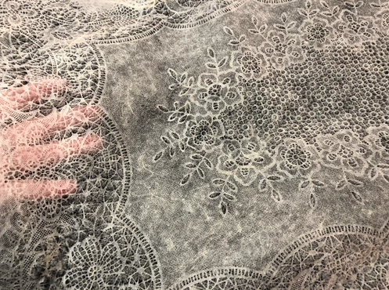Considering the special properties of humble paper fibers, artists explore cotton, abaca (banana leaf), flax, kozo and gampi (inner bark fibers) creating works beyond typical handmade sheets. This exhibition celebrates the many qualities of various fibers - translucency, fluidity, lightweight, strength, malleability, as these natural materials transform into delicate veils, fantastic dimensional structures, pulp drawings and layered constructions. Through the processes of hydration, beating, forming, and drying these fibers create unusual effects and interactions.

A papermaking workshop is planned for February 8 & 9, 1:00 – 5:00

For further information contact:

[karen@constellation-studios.net](mailto:karen@constellation-studios.net)

402-429-8239